Architectural Pattern: A 3-Tier Machine Learning Pipeline.
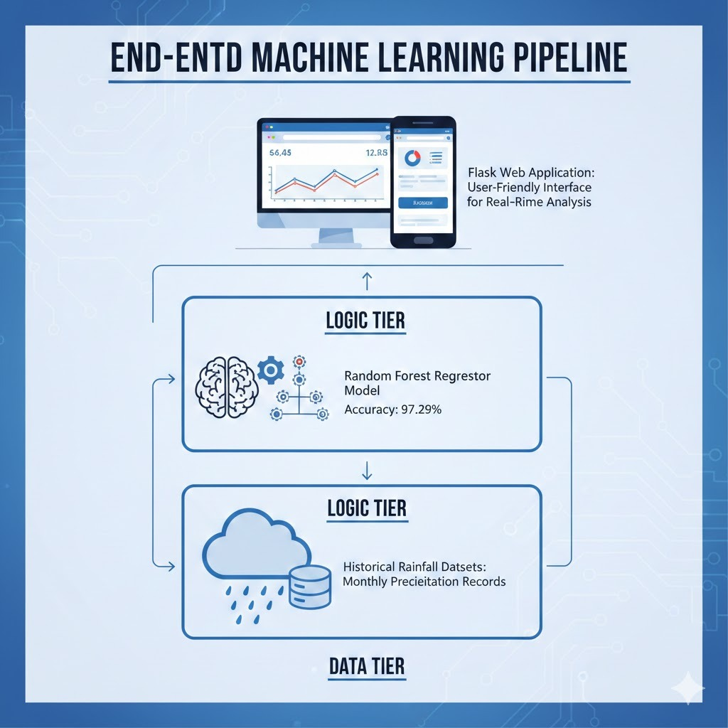
Data Tier: Houses the Rainfall.csv dataset, categorized by state and district (from Andaman & Nicobar to Arunachal Pradesh).
Logic Tier:
- Preprocessing: Implementation of Standardisable to ensure all monthly rainfall inputs are normalized before prediction.
- Model Engine: A Random Forest Regressor trained on an 80/20 data split (512 training rows, 129 testing rows).
Presentation Tier (UI/UX Design):
- Frontend: Designed with HTML5 and Bootstrap for a mobile-responsive experience.
- Glass morphism: The interface uses modern CSS effects like backdrop-filter: blur(10px) and semi-transparent backgrounds to create a professional look.

- Dynamic Gradients: The UI changes from blue (home) to green (success) or red (warning) depending on the prediction result.

